**Loknete.Dr. Balasaheb Vikhe Patil (Padma Bhushan Awardee) Pravara Rural Education Society's,**

** PRAVARA RURAL COLLEGE OF EDUCATION, PRAVARANAGAR**

A/P- Loni Bk.,413736,Tal- Rahata,Dist-Ahmednagar

Phone No.. (02422) 272844,272081

**NAAC Accredited 'B' Grade**

**I.d.No.PU/AN/Edn.036/(1990) N.C.T.E. Code: APW01953/113106**

# Email:- principal.bedloni@pravara.in Website - www.pravarabed.in

Ref.: PRCE/ Date: 15/06/2024

**Internal Quality Assurance Cell (IQAC)**

Notice

All the members of Internal Quality Assurance Cell (IQAC) are hereby informed that the 1st Meeting of IQAC will be held as per scheduled in academic calendar 2024-25 on 19th June 2024, at 02:30 p.m. in NAAC office.

**Agenda**

* Confirmation of the minutes of the previous meeting
* Formation of IQAC for the year 2024-25
* Discussion on to prepare and implementation of Academic Calendar for 2024-25.
* To prepare the annual teaching plan and workload distribution.
* Proposal under QIP to BCUD, SPPU, Pune.
* To conduct training programs for teaching and administrative staff.
* Implementation of newly introduced skills development courses.
* Review of Result analysis of last year.
* Preparation of time-table.
* NAAC- review of Criteria wise work status.
* Any other issues to be discuss with permission of Chairperson
* Date of the next meeting

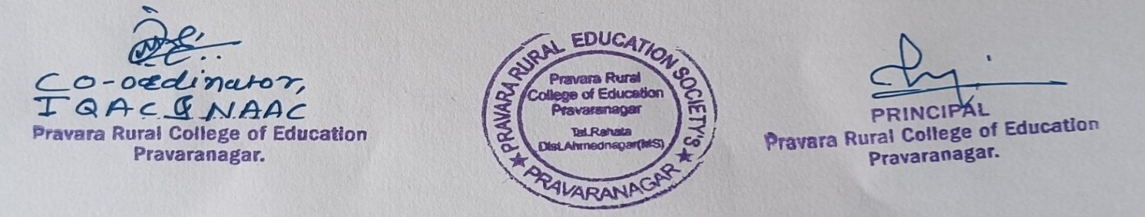

MINUTES OF THE MEETING

|  |  |  |  |  |
| --- | --- | --- | --- | --- |
| Meeting No. 1 | Time: 2:30 p.m. | Present Members:15 | Date: 19/06/2024 | Department/Committee: IQAC |

The 1st meeting of the Internal Quality Assurance Cell for the academic year 2024-25 was held on 19th June 2024 at 02.30 p.m. in NAAC office. The meeting was chaired by Hon. Prin. Dr. Vidya P. Waje. At the beginning of the meeting Prof. R.B. Morey, IQAC Coordinator welcomed the chairperson and all the members of the IQAC. The following agenda were discussed in the meeting, and it was unanimously resolves to accomplish them. The meeting was adjourned after vote of thank.

|  |  |  |
| --- | --- | --- |
| Sr. No. | **Agenda** | **Resolution** |
| 1 | To read and confirm the minutes of the last meeting. | The minutes of the previous meeting were ready the coordinator and confirmed. As per the minutes of meeting the action taken report was briefly discussed in the meeting |
| 2 | Formation of IQAC for the year. | IQAC committee has been formed and Approved by the principal. The 15 members were nominated by the chairman including IQAC coordinator. |
| 3 | Discussion on to prepare and implementation of Academic Calendar for 2024-25. | Academic calendar prepared by IQAC. It was approved by the committee and It was decided to circulate it to staff, and to be uploaded on college website. |
| 4 | To prepare the annual teaching plan and workload distribution. | It was decided that to distribute workload. All teachers will prepare subject wise teaching plan and also prepare departmental planning. The copy of planning submits to IQAC department. |
| 5 | Proposal under QIP to BCUD, SPPU, Pune | The chairman proposed that proposal committee should prepare various proposals under QIP for getting funds from BCUD, SPPU for organizing seminars, purchasing equipment etc. |
| 6 | To conduct training programs for  In-service teacher and administrative staff. | It was decided that IQAC and Head office of PRES will conduct a In-service teacher and non-teaching staff training programme to inculcate modern skills and techniques of teaching among them for quality education. |
| 7 | Implementation of newly introduced skills development courses. | It was decided to implement two certificate courses i.e Soft Skills approved by MSSDS. Establish Acharya Chanakya Kaushyalya Vikas Kendra under PMSEDM. |
| 8 | Review of Result analysis of last year. | Review of subject and faculty wise result was taken by the chairman and congratulated teachers for their efforts and gave suggestion to teachers whose results were not up to mark. |
| 9 | Preparation of time-table | The principal have suggested preparing time table as per required weekly, Monthly including practical periods. |
| 10 | NAAC- review of Criteria wise work status. | The IQAC Co-ordinator have reviewed criteria wise work.  The IQAC suggested that to give much more focus on the work Library and establishment department. The Committee of NAAC peer team will visit for inspection In the next month. |
| 11 | Any other issues to be discuss with permission of Chairperson | Feedback taken at the end of previous year and Any other issues to be discusses with analysis report prepared by the feedback and it was appreciated by the chairman. |
| 12 | Date of the next meeting. | It was unanimously decided that the next of the 1QAC will be held in the first week of October. |

